**JENKINS:**

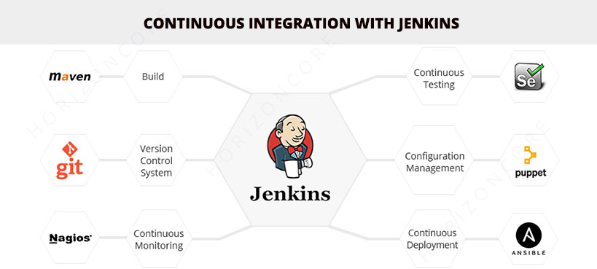

* Jenkins is one of the most popular tools for continuous integration purpose.
* Written in java, Jenkins is used to build and test software projects and also it is easy for developers to integrate the required changes to the project
* Jenkins began life at Sun Systems in 2004 as the Hudson Project. The name was later changed from the Hudson Project to Jenkins as a result of a dispute with Oracle in 2011
* Jenkins is an open source, supported by its global community

**BAMBOO:**

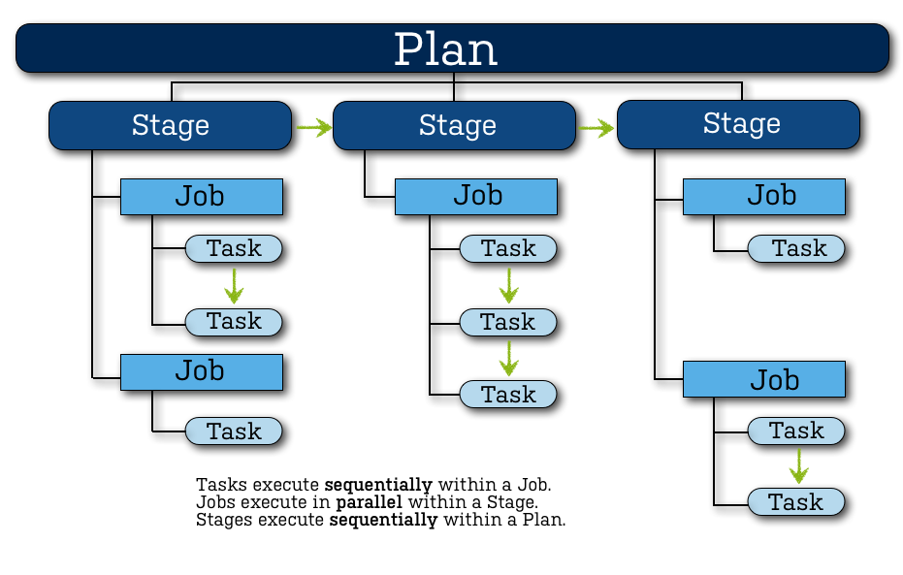

* Bamboo is an automation server used for Continuous Integration, written in java, it allows the developers to automatically build, integrate, test the source code for deployment
* Bamboo CI is a proprietary Continuous Integration and Continuous Deployment tool developed by Atlassian.
* Bamboo has its own dedicated team for its development

**TRAVIS CI:**

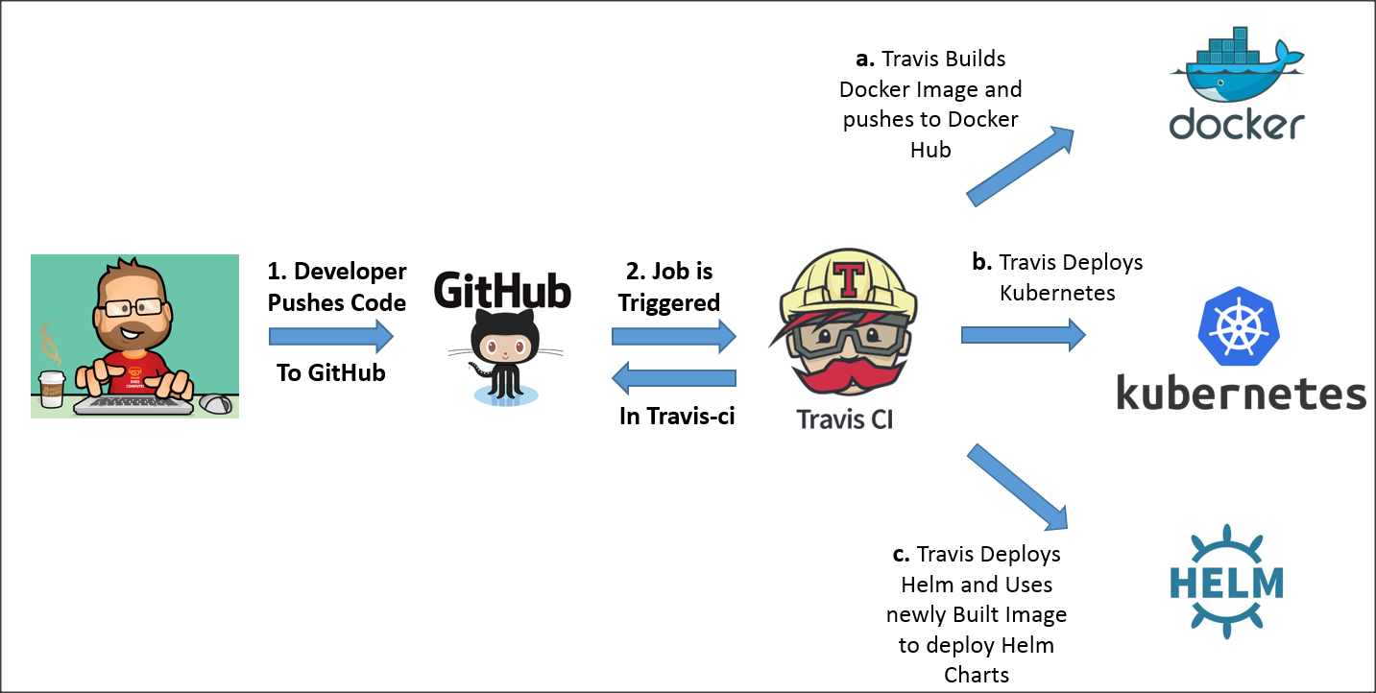

* Travis CI is a hosted continuous integration service used to build and test software projects hosted on GitHub and Bitbucket.
* Travis CI was the first CI service which provided services to open-source projects for free, however free open-source plans were removed at the end of 2020.
* Travis CI uses YAML as the primary language for build configuration stored in the main .travis.yml build config file
* Travis CI is a commercial CI tool

**Advantages of Jenkins over Bamboo & Travis CI:**

|  |  |  |
| --- | --- | --- |
| **Jenkins** | **Bamboo** | **Travis CI** |
| Jenkins is a free and open source automation tool.  Jenkins began life at Sun Systems in 2004 as the Hudson Project. The name was later changed from the Hudson Project to Jenkins as a result of a dispute with Oracle in 2011  Built in java that runs on Windows, macOS, and other Unix-like operating systems  can integrate with a variety of repository systems  Supports over 1000 plugins  User interface is difficult to use but very customizable  most difficult to set up and requires more manual customization than Bamboo and Travis  If you’re looking for a cheap (free!) CI solution, are willing to put in the work to customize your environment and need support from a community of users, Jenkins is the choice for you.  Facebook, Netflix, Lyft, Ebay | Bamboo CI is a commercial tool originally provided both a cloud-based and on-premise version. As of 2017 however, the cloud-based version has been discontinued.  Bamboo CI is a proprietary Continuous Integration and Continuous Deployment tool developed by Atlassian. Within Bamboo, you have Projects, Plans, Stages and Jobs.  Built in java that runs on Windows, Linux, Solaris, and macOS  can integrate with a variety of repository systems  Supports Atlassian Plugins (approx 200 total)  Easy to use and intuitive but customization is limited  easy to set up and is especially easy for those new to continuous integration  Bamboo is powerful as long as you’re using it with Bitbucket and JIRA, and are willing to pay for your CI solution  Poll Everywhere, Hello Labs, StumbleUpon, StudyBlue | Travis CI comes in both an open source and an on-premise, enterprise version  Travis CI, the popular Berlin-based open-source continuous integration service, has been acquired by Idera, a company that offers a number of SQL database management and administration tools for both on-premises and cloud applications  Built in ruby that runs on Linux and macOS  can only be integrated with GitHub as a repository  Not as many Plugins as Jenkins  Nice easy to use interface  easiest and quickest to set up. Travis CI is entirely cloud-based, so all users need to do is sign up and set up their project  If your code is open source and you’re more concerned about the continuous integration of your builds, Travis CI is worth a try  Heroku, MIT, DuckDuckGo, Sentry |